**Stages_Hands_On_Exercise**

**Step 1: Open Snowsight and create a new worksheet, create a table and stages as shown below using SYSADMIN**

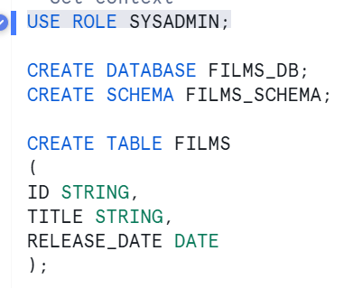

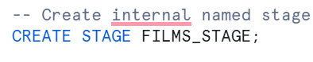

**Step 2: Connect to snowsql**

***Command:*** snowsql -a HOJZGKX-QY24209 -u geedhuvj -d FILMS_DB -s FILMS_SCHEMA -r SYSADMIN -w COMPUTE_WH



**Step 3: Put file into the User Stage**

***Command:*** PUT file://C:\Users\Geedhu\Documents\Geedhu\Snowflake\Udemy\SnowPro_Core_Course_Hands-on_Resources\Hands-on-Queries\D3\films.csv @~ auto_compress=false;



**Step 4: Put file into Named stage and Table stage**

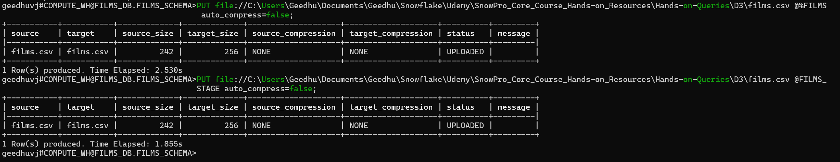

**Step 5: Scenario to check if duplicated file are skipped.**

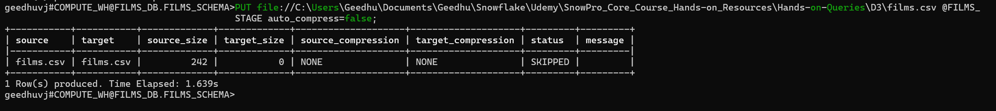

Step 6: List the files in snowflake and see

